1 Can you find and open the text editor program on the main menu? *(Hint: It is under the Accessories sub-menu)*.

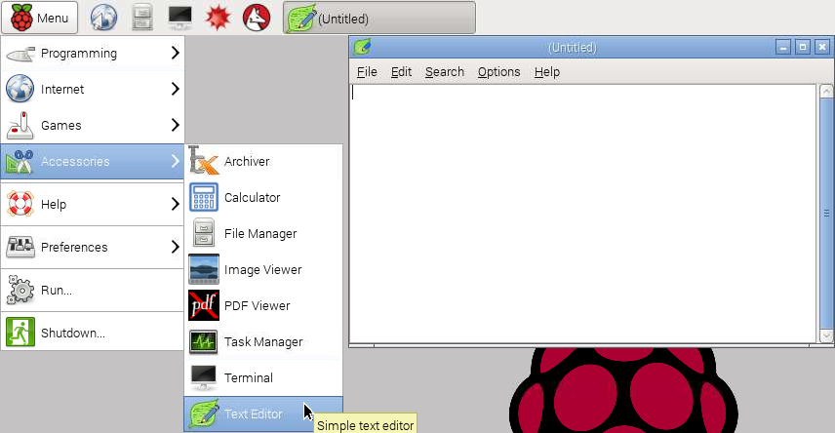

2 You can type any text you like into the file.

3 When you are finished typing you would like to save the file. Click the File menu, then the Save As menu item. This opens the save as dialog

3 You can choose a location and name for the file (which should use the format YourFileName.txt) then click save.

